Using lidar to study the effects of microtopography and structure on spruce sapling function at northern treeline

Andrew J. Maguire, Jan U. H. Eitel, Lee A. Vierling, Daniel M. Johnson, Kevin L. Griffin, Natalie K. Boelman, Johanna E. Jensen, Arjan U. H. Meddens, Jyoti S. Jennewein

1. **Introduction**

**Why:** Why are we doing this/studying this?

One of the world’s largest ecotones/Warming is 2-3 times faster 🡪 Leading edge (saplings) will be particularly susceptible to environmental change.

**Local vs. global:**

Local studies are necessary to understand fine scale processes that can mediate climate change effects

**Microstructure and topography:**

It is well known that microstructure and microtopography affect the physical growth environment which in turn affects plant function. 🡪 expand on this by giving concrete examples/cite appropriate work (as part of this make sure to define microtopography/discuss boundary layer).

**Lidar remote sensing:**

To get fine scale microstructure and microtopographic effects, lidar could be used. Lidar is a well established technology that allows to capture the 3d structure of objects …

**Research objective statement:**

Our objective was to test the influence of microtopographic variables on sapling function. Due to our knowledge that topopgraphy affects the physical growth environment we hypothesized that microtopography affects sapling function.

1. **Materials and Methods**

**2.1 Study site**

Field data were collected along an approximately 3 km long north-south transect at the FTE near the Dalton Highway (XX°XX′ N latitude, XX°XX′ W longitude) , Alaska, USA (Fig. 1). Along this transect, trees are increasingly sparse and the landscape eventually transitions into treeless tundra. Mean precipitation and air temperature for the study area measured by a nearby SnowTelemetry (SNOTEL) site is xxx and xxx, respectively. The forest underlain by (continuous?) permafrost consists of both black (Picea mariana) and white spruce (Picea glauca) with sedges and low-stature deciduous shrubs (e.g., Betula nana L.) in the understory

Wind was measured …

Study site selection (beyond mature tree stands > 2 meter in height – see Holtmeiers definition of treeline). Important to emphasize: A total of four nurseries were established to capture the full variance in performance and condition across the ecotone.

Sapling we selected were below average snow depth during winter of 2015 (get info from SNOTEL)

**2.2 Fluorescence**

Make sure how needles for fluorescence measurements were chosen.

Dark adaptation (how long)

**2.3 Terrestrial lidar scanning**

Terrestrial lidar scanning (TLS) data was acquired with the Leica ScanStation C10 (Leica Geosystems Inc., Heerbrugg, Switzerland). This time-of-flight laser instrument has a beam divergence of 0.14 mrad, a scan rate of up to 50,000 points s-1, a maximum sample density of < 1 mm, and a maximum range of 134 m at 18% albedo. The distance accuracy is quoted as 4 mm and position accuracy as 6 mm. Crown height for each of the 36 trees was derived from the georegistered TLS point cloud by identifying the top of crown and base of bole points, respectively, using Cyclone 9.1 (Leica Geosystems Inc.) and calculating the difference of the z-values of UTM coordinates (Figure 2).

**2.4 Microtopographic variables**

The wind radius for the windshelter calculation was empirically determined by varying the wind radius between 1.0 and 5.0 pixels.

Define microtopography: Microtopography in this study is defined by processes that are within cm to meter scale/All variables are within a 2 meter search radius since this study is focusing on

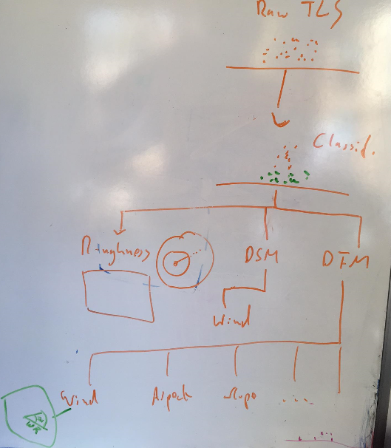

**2.5 Data analysis**

Account for spatial autocorrelation

Random forest

All covariates totaled 163 (eight terrain metrics of 20 scales each, plus nursery ID (categorical), plus sapling height, plus sapling prominence) and were reduced for the purpose of avoiding excessive collinearity and weakening of variable importance from Random Forest modeling.

Within each “scaled” covariate (eight), starting at 0.1 m search radius from the sapling location and moving up at 0.1 m increments, any scales at which Pearson’s correlation coefficient, r >= 0.90.

Then, each covariate at the remaining scales was compared together in a correlation matrix for those pairings with r >= 0.9.

[Regression modeling]

1. **Results and Discussion**

**3. Results and Discussion**

3.1 Random Forest modeling

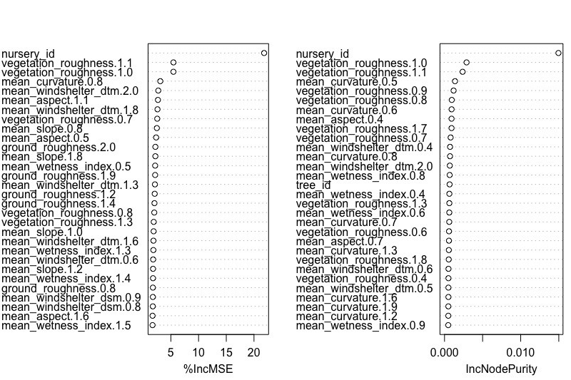

Key figure to show here is the importance plot

Overall model performance (percentage of variability explained)

3.2 Windshelter

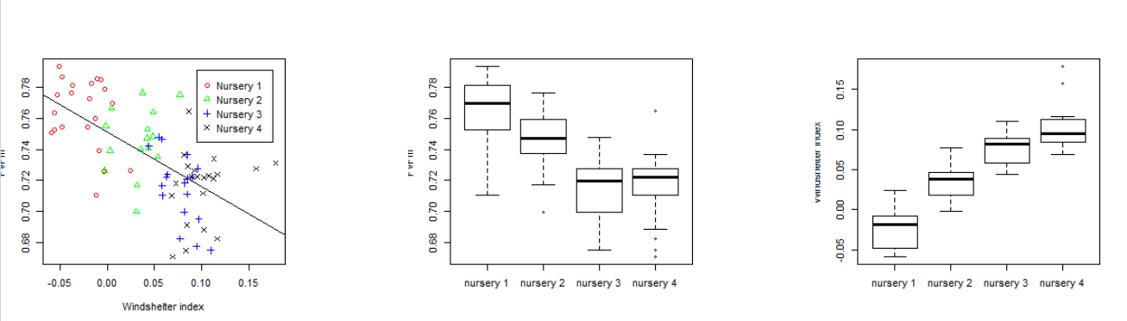

* 1. Prediction map

Map plant

Limitations:

* These are saplings and not trees (are within boundary layer and hence might perform/respond to variations in structure differently).
* Wind direction is based on summer wind direction 🡪 can we assume windshelter values are also true for the winter time (e.g., main wind direction might change).

Other factors affecting tree function (e.g, Soil nitrogen availability).

1. **Conclusion**

**Acknowledgment**

The funding for this work came from NASA Terrestrial Ecology grant NNX15AT86A and NASA ABoVE grant (Eitel-01). Thank you to Professor Brenning for some of his insights on the windshelter algorithm implemented in RSAGA.

**Next steps:**

* Have conversation with Kevin and Dan about data and how to interpret them

Specific questions: Would you be concerned about the significant differences in fluorescence between nurseries given that there were several days between fluorescence measurements?

Dan 🡪 ask the best way to present windshelter regression

* Contact Arjan and/or Carlos about random forest modeling and variable selection
* Include Canada lidar data?